Rejuvenation of the Penticton Oxbows
A Conceptual Management Plan

February 2016
Updated December 2016
The Friends of the Oxbows
Penticton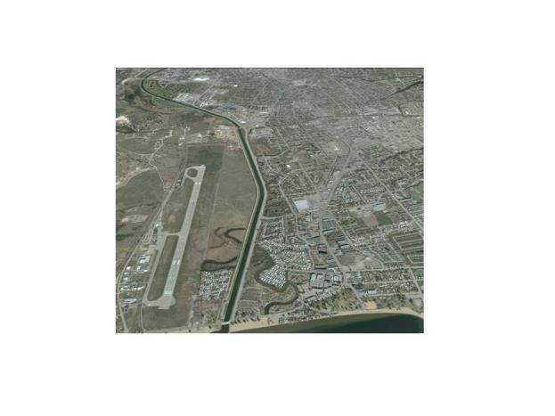

Contents
Introduction 4
Background 5
Management Prescriptions 7
General Considerations 7
Loco Landing/Riverside Marsh 8
Overview 8
Management 9
Ellis Creek Basin 10
Overview 10
Management 10
Warren Ave oxbow 11
Overview 11
Hydrology 11
Water Quality 11
Wildlife Use 12
Management 12
Kinney Ave oxbow 13
Overview 13
Hydrology 13
Management 13
Falcon Court oxbow 14
Overview 14
Hydrology 14
Management 15
Brandon Ave oxbow 15
Overview 15
Hydrology 16
Water quality 17
Management 17
Campi oxbow 17
Yorkton Ave/Skaha Place oxbow 18
Overview 18
Management 18
Old River Mouth at Skaha Lake 19
Overview 19
Management 19
ECOmmunity Wetland 20
Overview 20
Management 20
Airport Wetlands 22
Overview 22
Management 23
Appendix 1. 25
Loco Landing/Riverside Marsh 27
Ellis Creek Basin 28
Warren Ave 29
Kinney Ave 31
Falcon Court 32
Brandon Ave 33
Campi oxbow 36
Yorkton Ave/Skaha Place 36
Old River Mouth, Skaha Lake 38
ECOmmunity wetland and lowland forest area 39
Airport Wetlands – North Pond, South Pond, and Remnant Oxbow. 40
Appendix 2. Summary of bird and turtle counts from data collected February to October 2015 by the South Okanagan Naturalists Club 43
Appendix 3 Graphic summary of pH and conductivity at the Brandon Ave oxbow for the period May 2015 through September 2016, and at other sites in late 2015 to September 2016. 45

Introduction
The Okanagan River between Okanagan and Skaha lakes has been altered extensively over the years, from a meandering course with abundant riparian vegetation, to a channel through a highly developed landscape. What were once natural meanders of the Okanagan River have become cut off from the now channelized river, and are stranded as old river channels, or “oxbows”. Where river processes once maintained these wetlands and riparian areas, there are now only remnant wetlands rapidly in-filling, with much diminished riparian vegetation.
The Friends of the Oxbows is working to rejuvenate the wetland oxbows in the Penticton area. We believe there are opportunities to restore riparian vegetation, improve water quality and water flow, and manage invasive species. We think there is a significant opportunity to showcase these wetlands much more positively, with minor improvements. While no one is advocating a return of the river to its former channel, the Friends of the Oxbows believe the remaining wetlands should be better managed. What one sees now on entering Penticton along Highway 97 is a collection of rather degraded, remnant wetlands, fragmented and enclosed by roads and other developments.
Wetland rejuvenation would serve three major purposes: 1) a much more enlightened approach to wetland and water conservation by the City of Penticton and the Penticton Indian Band would be immediately evident, consistent with the region-wide concern about the need to conserve and manage water; 2) the entrances to Penticton on Hwy 97 would be much more attractive, consistent with Penticton’s contention that the city is a desirable community to visit and live in; and 3) these wetlands would provide for increased levels of biodiversity and endangered species management, and passive recreation such as nature appreciation.
What follows is our conceptual plan for improvements to the oxbow wetlands still present in the Penticton area. For each oxbow identified we present our ideas as to what needs to be done to maintain them as productive wetland ecosystems. We provide a synopsis of knowledge for each, suggest management prescriptions to improve water quality and increase biodiversity, and preliminary estimates of cost. Measures of success for all management prescriptions will be increases in the area of riparian vegetation, maintenance of open water areas, increases in species diversity and numbers of birds using each oxbow, and increases in sightings of endangered species such as the Western Painted Turtle.
The oxbows we are focusing on in this plan are the eight wetlands lying on the east side of the Okanagan River Channel and the four wetlands on the west side of the channel (Fig. 1). Concerns for the well-being of all those wetlands are similar. Friends of the Oxbows have chosen to focus mostly on the oxbows on the City side of the Channel. Management of those on the west side is being addressed by the En’owkin Centre, in the case of the northwestern wetland, and the Penticton Indian Band and the Okanagan Nation Alliance for the three wetlands south of the airport. All the oxbow wetlands remaining in the area between Okanagan and Skaha lakes are dealt with in this report.

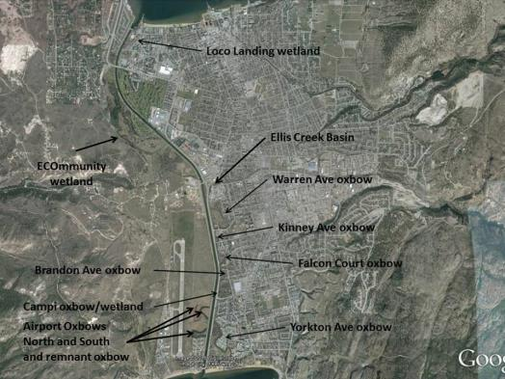
Figure 1. Location of wetlands and oxbows for proposed restoration.

Background
The City of Penticton has been developed on post-glacial deposits from Penticton, Shingle and Ellis creeks. As the ice from the last advance retreated from the valley a large lake (Lake Penticton) formed extending beyond where the two lakes now exist (Okanagan and Skaha lakes). The fans of Penticton, Shingle and Ellis creeks built up in the valley bottom, eventually splitting the large lake in two (Nasmith, H. 1962. Late glacial history and surficial deposits of the Okanagan Valley British Columbia. Bull 46, BC Dept of Mines and Petroleum Resources, Victoria). Flowage southward from Okanagan Lake to Skaha Lake continued, in spite of the buildup of sediment in the valley bottom, in the form of the Okanagan River. As the grade of the Okanagan Valley is gently sloped to the south, the Okanagan River meandered through these creek sediments, forming wetlands and oxbows between the two lakes. Between Okanagan Lake to the north and Skaha Lake to the south an extensive area of riparian wetlands and marshes developed, with the Okanagan River meandering throughout.
As Penticton was settled by Europeans the wetlands adjacent to the Okanagan River began to be modified. Dams were built at the outflow of Okanagan Lake to regulate water flow downstream and to begin to manage the landscape and attendant wetlands for agriculture and settlement purposes. The wetlands began to disappear, and a range of migratory bird and fish species dependent on them began to decline in numbers. The river channel was used by the Canadian Pacific Railway to move barges between the two lakes, to facilitate commerce up and down the valley. Over time, this use of the river necessitated periodic dredging of the channel and the construction of retainers to control water flow, sedimentation and erosion. Other uses were made of the river as development proceeded, including log rafting for lumber milling, other small industrial uses, farming, and eventually housing. At the same time flooding of various parts of the Okanagan valley was at least an annual threat, putting at risk various infrastructure developed as settlement of the valley progressed. After a particularly bad flood episode in the late 1940’s, a major change to the drainage between Okanagan Lake and Skaha Lake was proposed, culminating in the river channel seen presently (see Figures 2 and 3). Where once the Okanagan River meandered through the landscape, a straight river channel resulted. The large loops the river made through Penticton were cut off from the channel and left more or less as oxbow wetlands, with no or limited connection to the main river channel.

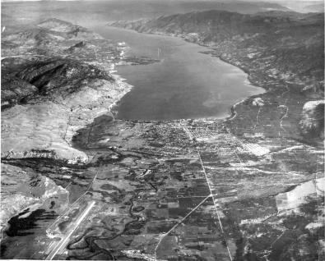
Figure 2. Penticton circa 1940 showing extent of wetlands and meanders associated with the Okanagan River before channelization (Courtesy Penticton Museum and Archives).

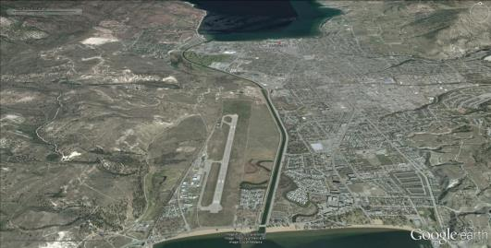
Figure 3. Penticton circa 2015 showing Okanagan River channel and remnant wetlands.

With the increased level of water management that resulted from the river channelization came more settlement. The oxbows became the receiving environment for stormwater runoff from adjacent roads, and houses were built along the wetland edges to the east. Riparian plant communities were reduced, and exotic species introduced. Deposition of various forms of debris and high rates of siltation, combined with almost no water circulation, accelerated the decline of these wetlands. According to Lea (Lea, T. 2008. Historical (pre-settlement) ecosystems of the Okanagan Valley and the lower Similkameen Valley of British Columbia – pre European-contact to the present. Davidsonia 19:1 3-35) the dominant vegetation that developed pre-European settlement would have been primarily Water Birch-Red Osier Dogwood riparian shrub swamp, with smaller areas of Black Cottonwood-Red Osier Dogwood Riparian forest near the confluences of Shingle and Ellis creeks with the Okanagan River. Presently, these communities still exist, albeit much reduced in extent, and there are many other, mostly exotic, species mixed in with them, such as Weeping Willow, Russian Olive, Siberian Elm, and Tree of Heaven, to name just a few.

Management Prescriptions

General Considerations
By and large the oxbows need to be relieved of built up sediments (see specific details for each oxbow below), the banks resloped, and if possible, reconnected to flowing water. The ideal slope for most oxbow banks will be 1:3, and the minimum required water flow is in the order of 0.5 cms. The logical source for flowing water for oxbows on the east side of the channel is Ellis Creek, subject of course to fisheries concerns. For those on the western side of the channel, pumping or syphoning from the channel itself is the likely best source of flowing water. For one endangered species, the Painted Turtle, a small amount of a sand/gravel mix needs to be placed somewhere on each oxbow in an area with a south and west exposure for turtle nesting habitat. Finally, in recognition of the joint effort that will be required to rejuvenate our oxbows, signs should be placed recognizing all those involved in these undertakings.

Data Collection
A very limited amount of data exists on the biology or abiotic factors associated with the Penticton oxbows. This makes it difficult to both prescribe what improvements could or should be made, as well as to assess the efficacy of any such improvements that are made. To date we have approximately one year of data on a minimal water quality measurement scheme (pH, conductivity and temperature), and we have two years data on bird use of most oxbows on the east side of the channel, thanks to the efforts of the South Okanagan Naturalists Club. Little is known of hydrology, or bathymetry, except where noted below for specific oxbows.
We believe a baseline of at least three years of data should be collected on water quality, and more data should be sought for more specific chemicals such as those associated with storm runoff, and pharmaceuticals.
Likewise, two to three years of data on fish, amphibian, reptile, bird, mammal, and invertebrate species abundance and numbers would be ideal, before any rejuvenation takes place. Changes in diversity and abundance of those elements will be used to assess the success of any improvements made to the oxbows. As little is known of the health of the oxbows, in comparison to other similar systems not serving as urban wetlands, data are needed for such an assessment. It is proposed that some form of benthic monitoring be implemented as resources become available (see Jensen, V. 2007. The Biological Integrity of Okanagan Streams: Using Benthic Invertebrates to Monitor Stream Health. Environmental Protection Program, Ministry of Environment, Penticton BC). Finally, a more complete inventory and measure of plants cover is required, before and after rejuvenation efforts.

Loco Landing/Riverside Marsh

Overview
The wetland in the vicinity of Loco Landing (see Fig. 4) is part of the original river channel exiting Okanagan Lake and was cut off from the river during construction of the current channel. It appears to have only surface drainage and perhaps some groundwater seepage as its current source of water. Water remains in the wetland for only short periods, although the soil appears to remain moist most of the year. There are some wetland plants visible, mostly cattail (see photos in Appendix 1), and the banks are dominated by the introduced Crack willow (Salix fragilis), one or two Wheeping Willow (Salix babylonica), and a few relatively large native Black Cottonwoods (Populus trichocarpa). A variety of mostly non-native grasses and other weedy plants are also present. The total area of this wetland is estimated at approximately 1000m², with a perimeter of 770m.

Management
Development of parking has severally impacted this wetland in the past, and there have been proposals for further encroachment as part of the City’s plan to upgrade the waterfront in the vicinity of the SS Sicamous. However, instead of further degrading what habitat remains, re-wetting the area could be accomplished by a small diversion from Okanagan Lake above the dam, as part of the proposed redevelopment. With the cooperation of the City, the Penticton Indian Band and the owners of the Loco Landing entertainment centre, an open channel (which once existed there) could be brought from the lake to the wetland, and a reconnection to the river channel constructed at the south end. As the Okanagan Nation Alliance has been actively recreating habitat for fish spawning in the river channel, reconnecting this wetland to the channel would also provide fish rearing habitat in close proximity to the new spawning areas. The restoration would also provide wetland habitat for other animal species and native plants as well as a natural viewing area.

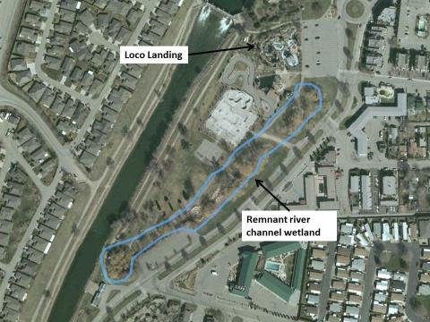
Skateboard Park
Figure 4. Wetland near Loco Landing which could be reconnected to Okanagan Lake and the Okanagan River Channel.

As this wetland has filled in over the years, most likely from accumulated organics from plant growth, a widening and deepening would be required. Some of the large willows might need to be removed, and cottonwood preferably replanted in their place. Weedy areas could be displaced over time by the planting of Red-osier Dogwood and wild rose species. A cedar rail fence could be constructed around the edge of the wetland to demark it from adjacent walking and park areas. The small bridge structure leading to the skateboard park would be retained as a viewing platform.
Costs are estimated to be in the order of $100k
Specific measures of success would include regeneration of native riparian vegetation to encompass between 25% and 50% of the wetland area, with the balance being in open water. The return of anadromous fish species and increased use by migratory insectivorous birds and other animal species will be taken as measures of success. There are currently no data on the use of the area by the birds and other animals, but surveys conducted before construction would provide a basis for comparison.

Ellis Creek Basin

Overview
At the end of Ellis Creek before it flows into the river channel a clean-out basin and small weir have been constructed to facilitate silt removal before the water enters the river. The basin is cleaned periodically as silt accumulates, with attendant impact on the riparian plants that grow up between service periods. Historically, Ellis Creek appears to have been of relatively steep gradient and somewhat braided, so presumably it was quite silty in the past. As the uplands of Penticton were developed Ellis Creek was straightened, increasing water velocity and scouring. As well, gravel pits upstream have been known to contribute high silt loads. The end result was a silty creek that would quickly clog the slow moving river channel if some form of silt interception were not in place.
There are fish in Ellis Creek, and in the fall a small run of Kokanee also make their way upstream. Recently, a spawning channel has been constructed just upstream from the creek’s entrance into the river channel. In spite of the fact there is little riparian vegetation at the creek’s mouth, the silt trap area appears to provide habitat for a considerable variety and number of birds (see Appendix 2).
Since the last clean-out of the silt trap attempts have been made to revegetate the surrounding banks. Numbers of riparian plants, complete with an irrigation system, were placed below the large culvert that once supported Industrial Ave (see Appendix 1 for photos). With some care this area may be revegetated still more to increase the productivity of the riparian habitat.

Management
As the basin is managed intensively on occasion for silt removal no further rejuvenation attempts are planned at this time. Sediment should be removed as required, but without complete removal of riparian vegetation. Current replanting efforts and animal use should be monitored and tended as required.

Warren Ave oxbow

Overview
The Warren Ave oxbow (Fig. 5) lies just south of Ellis Creek, and was once part of the main stem of the river. It is bounded on the east side by housing, and on the west is more or less wild, being undeveloped land owned by a locatee of the Penticton Indian Band. It has been modified significantly over the years from dredging, resulting in unnaturally steep banks on the Band side, and to a lesser extent on the city side. As a result the riparian area is somewhat restricted, and large trees have been impacted by beaver in many locations. The oxbow is currently divided into two compartments by an in-fill in the southeast corner, approximately where a pump-house once stood. A high-pressure gas main also passes under the northern compartment, coming across the adjacent locatee land and east into the city. There is an access from Warren Ave to the locatee owner’s property, via a culverted roadway.
The area of open water is approximately 9100m². The area of potential riparian habitat on the city side is approximately 6500m², though much of that area has been impacted by land owners (illegally) clearing land below their property lines to the water’s edge. The perimeter of the oxbow on the Band side is approximately 650m, and therefore the potential for longterm preservation of the riparian area, should the land be developed, would range from 650m² to perhaps 6500m², depending on what set-back is required by regulatory agencies. There is currently a plan to develop the locatee land for houses, which if implemented, will protect approximately the upper limit of riparian area estimated above.

Hydrology
Two culverts connect the oxbow to the river channel, one at each end. It is not known if these culverts are functional, but the water levels rise and fall seasonally in the oxbow. Local storm drains may be providing runoff from the roads, and there is one large storm drain main entering off Chatham Place. A silt interceptor was installed on this main in 2015 by the City. Water levels appear to fluctuate with water height in the river channel, so presumably seasonal fluctuations are to some extent caused by ground water intrusion. There are no data available yet on bottom contours of this oxbow, but it is presumed to be more or less flat, and composed of fine silts. Cattails grow in a narrow band along parts of this oxbow, indicating that water depths are likely greater than one meter a short distance from the banks (see photos in Appendix 1).

Water Quality
Preliminary data on water quality indicate this oxbow is somewhat basic, and of moderate salinity as indicated by conductivity measurements. Measurements made over the winter of 2015-16 indicated the pH ranged from 7.6 to 8.7. However, data collected two years previously by students from Okanagan College indicated that in October 2013 the pH was in the range of 6.9 to 7.0. Conductivity ranged from 266 to 530 mS, indicating relatively low levels of total dissolved solids and thus likely relatively low productivity.

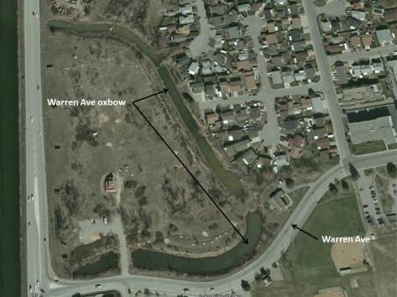
Figure 5. Warren Ave oxbow showing housing development on the city (east) side, and undeveloped locatee land to the west.

Wildlife Use
Bird surveys conducted from February to October 2015 indicate that this oxbow is used by a wide range of species, and gets more use than most other oxbows (see Appendix 2). Because of the extent of the open water ducks and geese are seen regularly, as are muskrat. Beaver sign is much in evidence, though this species, being primarily nocturnal, is rarely seen. Mule deer are also seen regularly, mostly on the locatee land.

Management
As part of the housing project proposed for the locatee lands adjacent to this oxbow, the proponents have suggested that they could make improvements to the oxbow by resloping the banks, removing the cross dike in the southeast corner, replanting riparian vegetation, and fencing off the riparian area on their development. On the city side riparian vegetation could be replanted on those areas where home owners have removed it, with some resloping in selected areas depending on proximity of the lot boundary to the oxbow water line. Any trees replanted would need to be protected from beaver. The south side of the main oxbow has suffered an almost complete removal of riparian plants as a result of beaver in the last eight to 10 years. Without considering some form of beaver management, regeneration of the riparian areas will be very difficult.
There is also an opportunity for controlled access for bird watching on the north end of this oxbow where the city owns a piece of land at the end of Okanagan Ave West. A small interpretive sign could be placed, and observation blinds or “hides” could be constructed here as well.
Three small storm drains enter this oxbow directly from adjacent roads. Silt interceptors should be considered for these drains, once some assessment of the amount of silt being deposited is made.
Anticipated costs, given the size of this oxbow, are in the order of $200k.

Kinney Ave oxbow

Overview
The Kinney Ave oxbow is relatively small, with commensurate light use by birds but with very heavy use by turtles (see Appendix 2). The area of open water is approximately 1700m², with about 500m² of riparian vegetation on the city side. The Band land is relatively wild, with a perimeter of approximately 120m, which could equate to up to 1200m² of riparian vegetation if the area were developed and the riparian area protected. The oxbow has silted in, and the riparian vegetation has been removed from near the houses on the east side. The west side is still relatively wild, but the riparian vegetation there is also somewhat sparse, though why is unclear. The west side area was originally within the Penticton Indian Band Reserve, but was cut-off from the reserve, likely during the construction of the channel. It is anticipated that this parcel will be returned to the Band at some time, though it appears rather small for any developments (see Fig 6).

Hydrology
The water sources for this oxbow are largely unknown, but it is likely that there is some inflow from local street storm drains. One large drain enters from Kinney Ave which may drain a significant area upslope. We do not know if there are culverts connecting it to the channel.

Management
The Kinney Ave oxbow would benefit from the removal of silt, and a general cleaning up. Riparian vegetation should be regenerated on the city side. Riparian plants could also be encouraged on the Band side, whether or not those lands are returned to the Band. The large storm drain entering from Kinney Ave should be monitored for silt flow, and an interceptor installed as required.
As this oxbow is relatively small, it is anticipated clean-up, including silt removal, could be accomplished for under $50k.

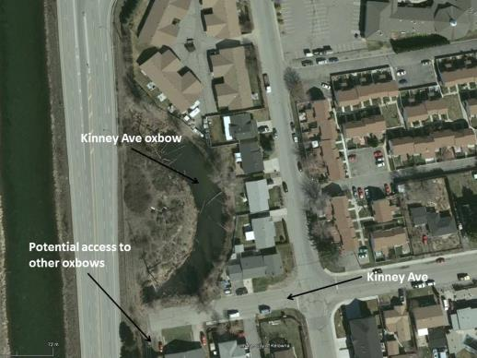
Figure 6. Kinney Ave oxbow

Falcon Court oxbow

Overview
The Falcon Court oxbow is approximately 2400m² of open water, with a variable amount of riparian vegetation remaining on both sides (see Fig 7). Riparian vegetation on the city side at the north end is relatively intact, due likely to the presence of fences along the lower lot boundaries of the houses situated there. The riparian area has suffered on the east and south sides of the city side due to its removal by adjacent land owners. As with other oxbows, the riparian area on the Band side is more robust. There is a road access and make-shift parking area off Kinney Ave to the north, behind several properties along the north end of the oxbow. There is also a public easement off either Falcon Court or Ayres Crescent allowing access to part of the wetland.

Hydrology
Three storm drains enter this wetland from adjacent streets. There are no large storm water mains entering. Culverts connecting the wetland to the river channel are not obvious, and water levels appear to fluctuate as the river level changes, indicating the major source of water is likely ground water. The oxbow appears to be silting up at the north end, where cattail has grown across the wetland along with a large stand of Yellow-flag Iris. Cattail is also present at the south end; that area is likely to silt up in the near future as this species extends into the open water. As cattail occurs in relatively confined areas the water depth is likely to be over one meter in areas without cattail. Having likely been dredged in the past the bottom is presumed to be relatively flat
.
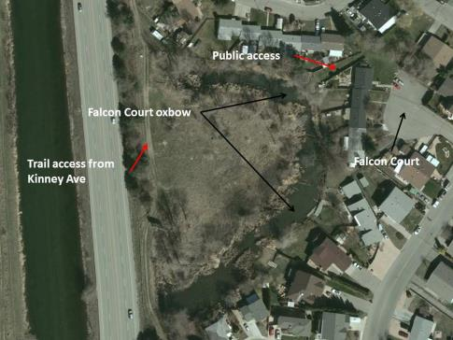
Figure 7. Falcon Court oxbow.

Management
This oxbow needs to have the silt removed, the banks re-sloped, and the riparian vegetation replaced on the city side. Storm drains should be monitored for silt inflow, and, as the oxbow is rapidly infilling, silt interceptors should likely be installed on all inflow pipes. Observation blinds could be placed at the public access points, and possibly on the north end of the oxbow near the path from Kinney Ave. Consultations with local landowners would be required.
Costs are estimated to be $70k.

Brandon Ave oxbow

Overview
The Brandon Ave oxbow is likely the most heavily impacted of all the oxbows (Fig 8). A large (1m) storm sewer main enters from Brandon Ave, which appears to be draining a large portion of southern Penticton (recently obtained information indicates this storm drain is actually a culverted stream, hence the large diameter pipe). Siltation was a major problem (see below), as has been the removal of riparian vegetation adjacent to the houses. In addition, the banks are very steep on the Band side, as a result of dredging in the past.
Until September 2016 the extent of open water on this oxbow was about 2000m², down from possibly as much as 4000m² in the past. The area of potential riparian on the city side is approximately 800m², though much of that has been lost or impacted by land owners clearing to the high water mark. On the Band side of the oxbow there is approximately 200m of perimeter, which if protected during any future developments would equate to a minimum of 2000m² of riparian area maintainable.
The City removed silt from this oxbow sometime around 2004. In 2014 the City installed a silt interceptor on Brandon Ave with the intention of reducing the amount of silt entering the wetland. Since the installation of the interceptor, approximately five m³ of silt were removed from the device in the first 10 months of its operation. Assuming a similar rate of siltation has been occurring in this oxbow since it was last cleaned out, upwards of 130m³ of silt may have been deposited in that time. In September 2016 the City re-dredged the oxbow, restoring the open water area to approximately 3500m². With the accumulation of organic debris from the extensive cattail beds present, this wetland was close to becoming a wet meadow, and no longer a marsh. That problem has been much alleviated by the recent clean-out.

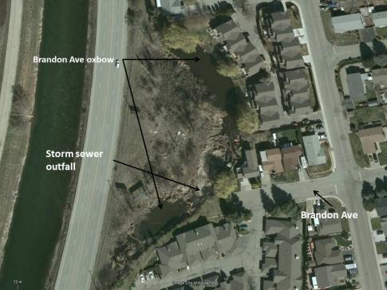
Figure 8. Brandon Ave oxbow.

Hydrology
There are two culverts at the south end of this oxbow leading to the river but nothing at the north end. Only one of the culverts at the south end is functional, the other having been covered with heavy screen and is now blocked with organic debris. Water levels fluctuate seasonally with those in the channel, and can change quite rapidly following a rain event as water enters from the storm drain. Besides the one large storm drain entering from Brandon Ave there is a smaller drain entering from Cornwall Court.

Water quality
Water quality data have been collected for most of 2015 at this oxbow. pH ranges from 7.5 to 10.6, the latter high reading coinciding with a major inflow of storm water in mid-November 2015 (see Appendix 3 for graphic display of these data). Conductivity ranged from a low of 111 S/m in the hot and dry part of the year, to a high of 2950 S/m, following a snow melt and runoff event. These high readings are likely a result of road salts being washed into the oxbow at that time. However, even though conductivity is very high at such times, conductivity appears to return relatively quickly to much lower levels, indicating that there must be a strong dilution effect within the oxbow. Either there is another source of much fresher water, or there is considerable interchange with the ground water. These high levels of conductivity or salinity do not seem to be having much effect on plant life in the oxbow, as the vegetation appears similar to that found in most of the other oxbows. Impacts of salinity on other elements of biodiversity however, are not at this time known.

Management
The amount of silt removed by the newly installed interceptor should be monitored annually. As much as possible the banks on both sides of the oxbow should be resloped. Riparian vegetation has been replaced where it has been damaged by the silt removal process. Currently, Friends of the Oxbows is working with landowners on the city side to encourage replacement of vegetation from their property lines to the high water mark. Given the heavy impact of silt from storm drains, it is recommended that an interceptor be installed on the drain entering from Cornwall Court, if silt loads warrant.

Campi oxbow
The Campi oxbow lies mostly on private land and is the least impacted of all the oxbows, except on the west side, where it more or less abuts the Channel Parkway (see photos Appendix 1). Adjacent to this oxbow there is also a large forested area, which appears quite wet, most likely classifiable as a swamp (McKenzie and Moran. 2004. Wetlands of British Columbia. BC Min of Forests. Victoria). It is likely representative of the type of forest that would have been quite widespread upslope from the meandering Okanagan River, pre-channelization.
The amount of silt entering from the storm drain on Green Ave should be investigated. It is possible this drain enters the river channel directly, but in either case if the amount of silt is large, and this drain appears to service a considerable area near Green Ave, a silt interceptor should be installed. No other actions are proposed at this time for this wetland, other than to encourage the continued good management of the riparian on the owners side, and perhaps use the existing riparian as a model of what other areas could or should look like.

Yorkton Ave/Skaha Place oxbow

Overview
Extensive erosion has occurred on the city side of this oxbow, perhaps initially from dredging for barge transport, but undoubtedly also as a result of land clearing to accommodate development. This is the largest of the oxbows, and has a long wind fetch in the northern half which contributes to the erosion problem. Erosion has been controlled by land owners to some extent with the placement of large concrete blocks into the water. This has resulted in the almost complete elimination of riparian vegetation on the city side (see photos Appendix 1).
The amount of open water is estimated at 2.2 ha. There is very limited riparian area remaining on the city side, but the perimeter is long, and if the riparian area could be restored there could be as much as 1.2 ha on the city side. The riparian area is relatively healthy on about half the property on the Band side, and as with other oxbows, if a minimum of a 10m setback in any future development was required, an additional 1.2 ha of protected riparian area would result. Currently, there is a wetland forest (swamp) on the Band side, containing many riparian species, with an estimated area of 3.1 ha. The remainder of the land is developed as an RV park, of approximately 7 ha, very sparsely vegetated and providing minimal or no riparian area protection (see Fig 9).

Management
Suggested remediation is to regrade the east shore in the northern half (Yorkton part) and armour with various grades of rip-rap, to reduce erosion rates and allow the regeneration of riparian vegetation through the rock. As this will in time affect the view scape from the trailer court, shrubs and not trees would likely be the best option for replanting. Beaver may be a problem, so protecting the regenerating and maturing plants with wire wrapping will be required. Silt interceptors should be installed on the drains at the north end of this oxbow, as they appear to drain a large amount adjacent upland. The drain entering from Yorkton Ave is likely not allowing much sediment to enter. As this is such a large oxbow with considerable erosion problems some sediment entering, through restored water flow, could be valuable in stabilizing and facilitating colonization of proposed armoured banks.
It’s not known why there are so many pond lilies (Nuphar spp) present in the southern end of this pond, but limited water movement, enhanced nutrient levels, a muddy substrate and other water quality factors are likely contributing. The presence of pond lily is acceptable, however a more limited distribution mediated by improved water movement and quality would enhance the diversity of aquatic species.
As a considerable amount of work will be required to stabilize and rejuvenate this oxbow, costs will be high, likely above $300k. However, with the very limited amount of riparian edge remaining on the city side, costs might be lower, if less extensive work is undertaken.

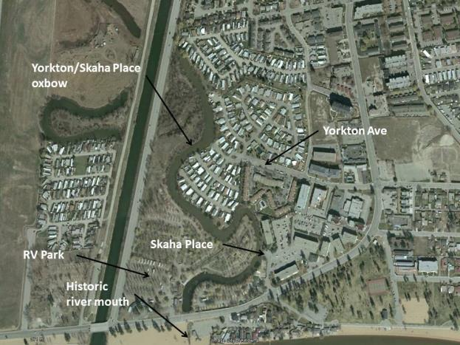
Figure 9. Yorkton/Skaha Place oxbow.

Old River Mouth at Skaha Lake

Overview
The old river channel exit to Skaha Lake exists as a small marsh east of the channel outlet directly south of the south end of the Yorkton/Skaha oxbow (see Fig 9.). It is obviously much reduced from what it was when the river entered the lake at this spot. While not connected now to the lake, except perhaps in high water, this remnant wetland appears to hold water most of the year. This may be a result of groundwater penetration, or there may be some minor flowage from the Yorkton/Skaha oxbow through the culvert under Skaha Lake Road.

Management
This wetland should be deepened to allow more water from the lake to enter, and widened to a minimum of five meters. This should encourage more riparian vegetation to grow up. As this is a public beach, consideration should also be given to public safety if a dense thicket of vegetation developed where none now exists (undesirable hiding place). This wetland would be enhanced if there were increased flow of water through the Yorkton/Skaha oxbow.

ECOmmunity Wetland

Overview
The ECOmmunity wetland is a stranded branch of the Okanagan River now bounded on the east by a piece of the Penticton Golf Course and by an extensive lowland forest on the west on the Penticton Indian Reserve (see Fig 10.). Area of existing open water is approximately 2500 m2. The area of the old river channel in total is approximately 1 ha. Existing riparian area on the City side is minimal, owing to the location of the golf course close to existing and historic open water areas. With some minor setback adjustments on the golf course, riparian area could be extended to approximately 2500 m² from 1400 m² existing now, if a 10m set back was observed.
The area of riparian vegetation on the Band side of the existing ponds is quite large, owing to the fact there has been no development there, and there is a large adjacent area of maturing lowland forest. Minimum riparian area that could be protected if the area was to be developed would be that which borders the wetland area now, about the same amount as on the City side, if a 10m set back were used on both sides (about 2500m²). If the old channel were to be reflooded, the area of riparian vegetation that could theoretically be protected would be approximately 6600m2 on the City side, if a 10m setback were enforced on the existing golf course. A similar amount could be protected on the Band side, in the course of any developments, although the existing riparian area/lowland forest is much more extensive than that.
The lowland forest and riparian areas on Band lands are of considerable conservation interest, though beyond the terms of reference of the Friends of the Oxbows at the moment. It is worth noting however, that efforts have been made to secure some of those lands through lease arrangements with the locatee, through an effort managed by the En’owkin Centre. Friends of the Oxbows strongly supports those efforts. There are few other such tracts of lowland forest anywhere on the Okanagan River, from Penticton to the US border, and there is nothing else like this in the Penticton area. Attempts to have this area preserved and managed in some way are encouraged.
There are no data known concerning water quality or wildlife use of the ECOmmunity wetland. Turtles likely are present, and a large range of migratory birds and other wildlife is likely also present, given the adjacent tracts of lowland forest and open fields. As the existing wetlands are not connected to the river channel in any way, and there are no known storm drain inlets, the likely source of the water at present is ground water intrusion, and run off from the escarpment to the west.

Management
It should be possible to do a number of things to enhance this oxbow. Minor adjustments to the fairways on the golf course could result in significant increases in the amount of riparian area on the City side. Silt removal from the existing watered area, and resloping of banks, would ensure longer-term maintenance of a productive wetland. Assuming removal of approximately ½ meter in depth of sediment, as there is a reasonable amount of open water there now, would remove approximately 1250m³ of sediment, at an approximate cost of $100k.
Rejuvenation of the entire course of the old channel is a possibility. That would result in an open water area of approximately I ha, and a potential riparian area with a 10m set back on the City and the locatee sides of approximately 6600m² each. Silt removal from the old channel other than those parts still watered would require going to a depth of approximately 1.5m, given that there is no open water in those areas now. Estimated quantity of material to be removed would be about 15000m³, and would cost in the order of $1.25m.
Getting water to flow through either the existing open water areas, or the much expanded area envisioned by completely excavating the old river channel, could be accomplished in either of two ways. The simplest would be to reconnect the old river channel at both ends with the existing river channel, assuming that the elevation of the rejuvenated channel was low enough. This would have the advantage of potentially reconstructing the old channel to become fish habitat, for which funds could possibly be sought from those sources used to undertake the Okanagan River Restoration Initiative (Phase I) near Oliver. Alternatively, a syphon or pump system could be installed at the north end of the channel, allowing water to move up into the oxbow, but limiting fish access. Syphoning would also depend on relative heights of both the wetland and the river channel. Costs for pumping would be in the order of $200k for installation, and $2500 annually for maintenance, power and depreciation.
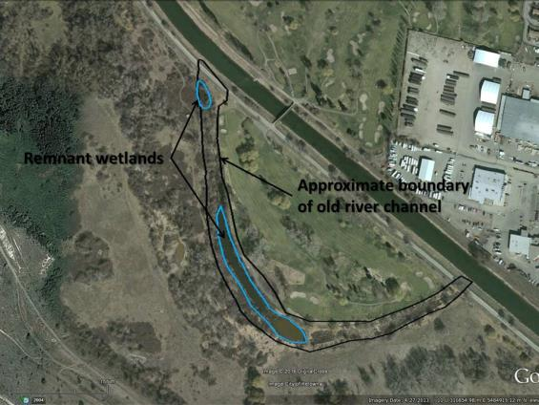
Figure 10. ECOmmunity wetland in relation to other lands on the west side of the Okanagan River Channel.

Airport Wetlands

Overview
The wetlands near the Penticton Airport consist of two segments of the old Okanagan River channel, now disconnected from the existing channel, and one true oxbow – a wetland that was once part of the Okanagan River but which was pinched off as an oxbow by natural river processes, likely well before European settlement of the area (Fig. 11). Lands surrounding those wetlands are heavily used, with a trailer park to the south, a cattle feed lot used intensively during the winter surrounding the northern wetland, and the airfield in close proximity. In spite of this heavy adjacent land use, there are still some relatively intact pieces of habitat close by, and opportunities for rejuvenation.

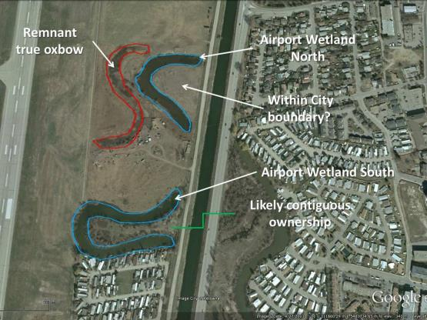
Figure 11. Oxbow wetands near the Penticton Airport.
The Airport Wetland North oxbow consists of approximately 6300m² of open water, with a perimeter of about 7600m, with very little riparian vegetation anywhere. The Airport Wetland South oxbow has about 1.3ha of open water, and a perimeter of 1100m. The riparian vegetation on this oxbow is in somewhat better shape owing to the fact that there has been no access to the peninsula (appr. 1.1ha) in its centre for some time, which now consists of a mix of riparian vegetation, including cotton wood, dog-wood, and wild rose. There is also some riparian vegetation remaining on the far western edge of this oxbow, and some trees along the south edge within the trailer park boundary.
The remnant “true” oxbow has no standing water on it, only apparently low, wet ground. Its area is approximately 8100m² with a perimeter of about 7300m. It appears to be well vegetated, but at the time of writing it is not known with what species. There are no riparian trees or any other remnant of riparian vegetation visible along either bank.

Management
There is much that can be done to rejuvenate the airport wetlands. The surrounding lands are primarily locatee-owned, and therefore any improvements attempted must be at their discretion. It should be technically feasible to do any or all of the following, with adequate resources, and landowner and Band agreement.
The Airport North Wetland oxbow should be fenced with a setback of at least 10m, with cattle being allowed access at only one or two locations, using in-pond fencing. The Nature Trust may be a possible source of funds for such an effort, as they have done much to protect wetlands and other scarce habitats recently in the South Okanagan through fencing. Riparian vegetation could be replanted, including such species as rose, Red-osier Dogwood, and Black Cottonwood. Forb and annual species, and emergent aquatic plant species, may still be present in seed banks in the soil, and will likely return quickly with the management of grazing. The peninsula in the centre of the Airport Wetland North oxbow could similarly be replanted, at least along its bank if suitably fenced. It would also make a good site for regeneration of lowland forest if cattle grazing could be eliminated.
Weeds, in particular Kochia Weed (Kochia scoparia or Bassia scoparia), appear to be a problem on the north side of the Airport Wetland North oxbow. Recommended management for this species is mowing in the spring after it has grown up somewhat, for use as silage (high in protein - http://beefmagazine.com/grazing-systems/kochia-good-bad-and-ugly), followed by disking and replanting with fall rye or another annual cereal (http://www.gov.mb.ca/agriculture/crops/weeds/print,managing-kochia.html). Kochia is an annual that sets a large number of seeds, but it does not apparently create much of a seed bank. Once it has been replaced with other grasses other desirable riparian species can be planted into the grass pasture, such as rose, Red-osier Dogwood, and Black Cottonwood. Any kochia plants that mature should be removed by hand before they form tumble weeds, which will help limit its spread in the future.
If the peninsula between the arms of the Airport North Wetland oxbow is provincial crown, as indicated on the Canada Lands Survey System map browser (http://clss.nrcan.gc.ca/map-carte-eng.php), efforts should be made to determine if it’s leased, and if so see if it can be managed in a more suitable fashion. If use of this area is in trespass then a Lands Act disposition by a conservation agency should be sought, to allow it to managed to regrow a lowland forest stand.
The Airport Wetland South oxbow should be treated similarly to the Airport North Wetland oxbow as much as possible. The riparian area in the peninsula between the two arms appears healthy, and requires little management. Where possible set back fencing on the outer sides of the oxbow should be installed, and riparian species replanted or allowed to regenerate naturally. It seems unlikely much can be done on the south bank of the Airport South Wetland oxbow, but it should be determined if the homes situated there are in trespass of the lot boundaries. If they are not in trespass it is likely there is little that can be done, unless the homes are relocated away from the water’s edge.
Both Airport Wetland oxbows appear to be relatively deep, as there is little or no ingrowth of cattail. Dredging seems unwarranted at this time. However, water flow through both oxbows is recommended. Likely this would require pumping, but reconnection with the channel, either with inlet and outlet pipes, or with full level reconnection could be undertaken, particularly if a major positive impact to fisheries could be demonstrated.
The remnant true oxbow will require dredging to a depth of at least a meter, in order for open water to be present again year round. That would require the removal of approximately 8000m3 of material, at a cost of approximately $600k. If flowing water is desirable this wetland could be connected to the Airport North Wetland oxbow, if flowing water was available there. Bank sloping should be 1:3, and riparian vegetation should be replanted as recommended on adjacent oxbows.

Appendix 1.
Historic photos of the extent of wetlands in the Penticton area in the past, and photos of each oxbow showing habitat characteristics mentioned in the text.

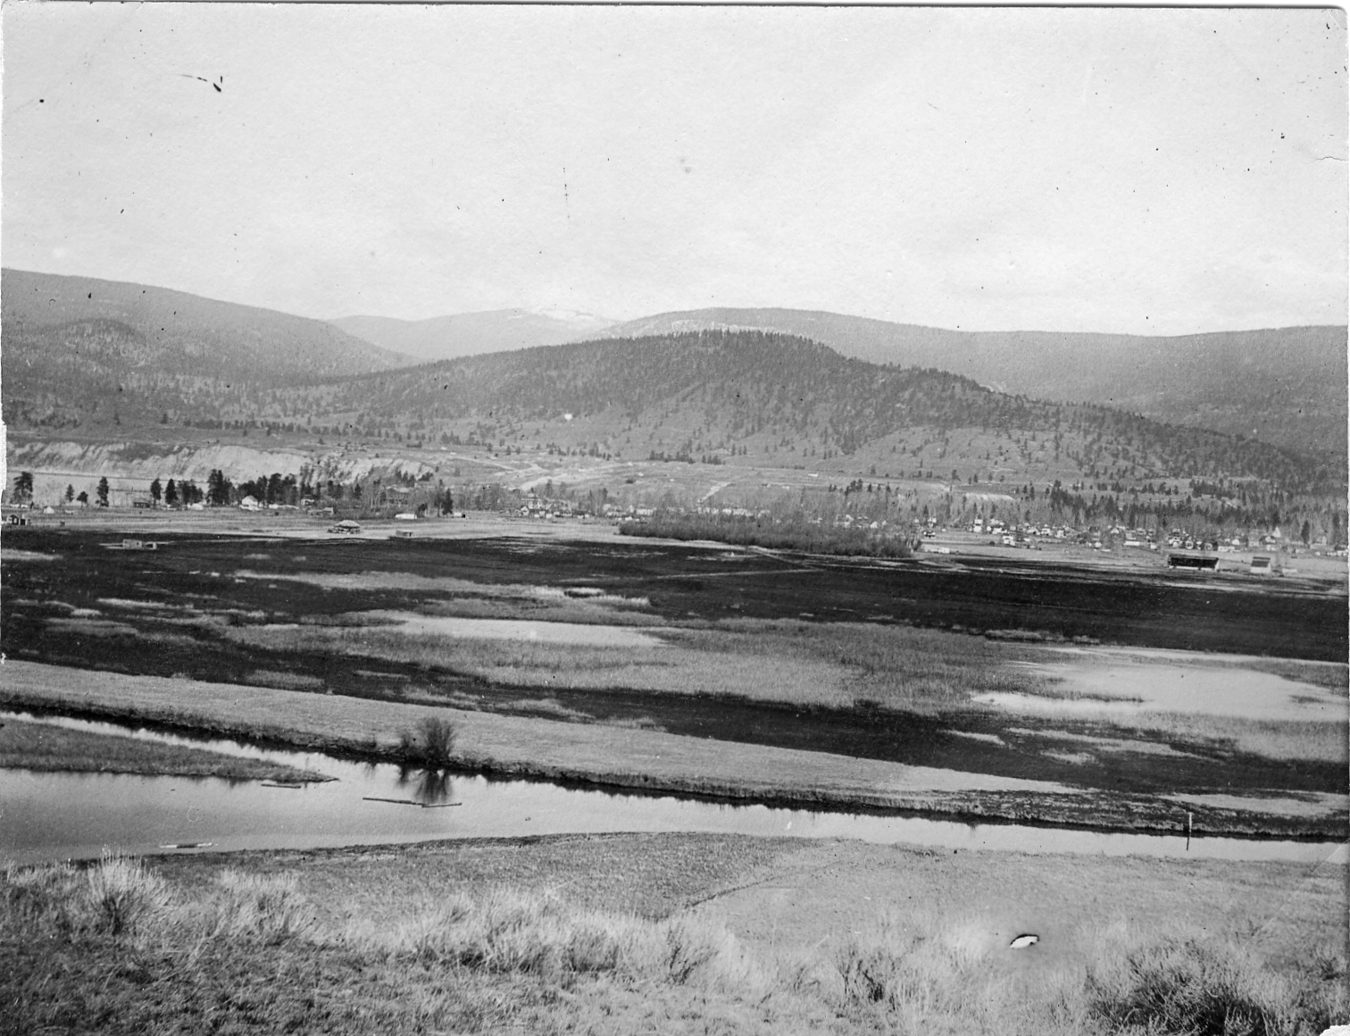
Wetlands near the entrance to the Okanagan River at Okanagan Lake (Penticton City Archives)

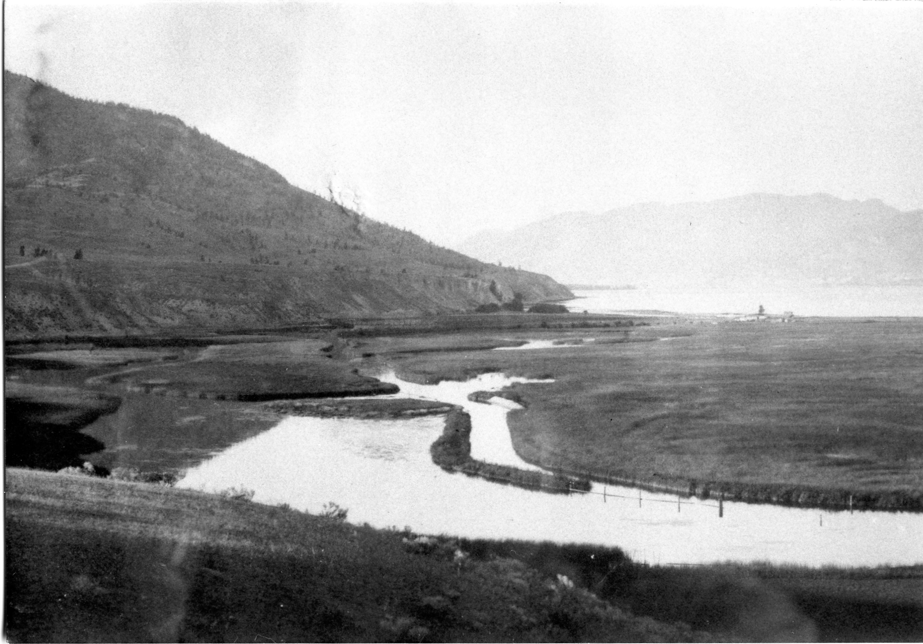
Wetlands at the south end of Okanagan Lake (Penticton City Archives)

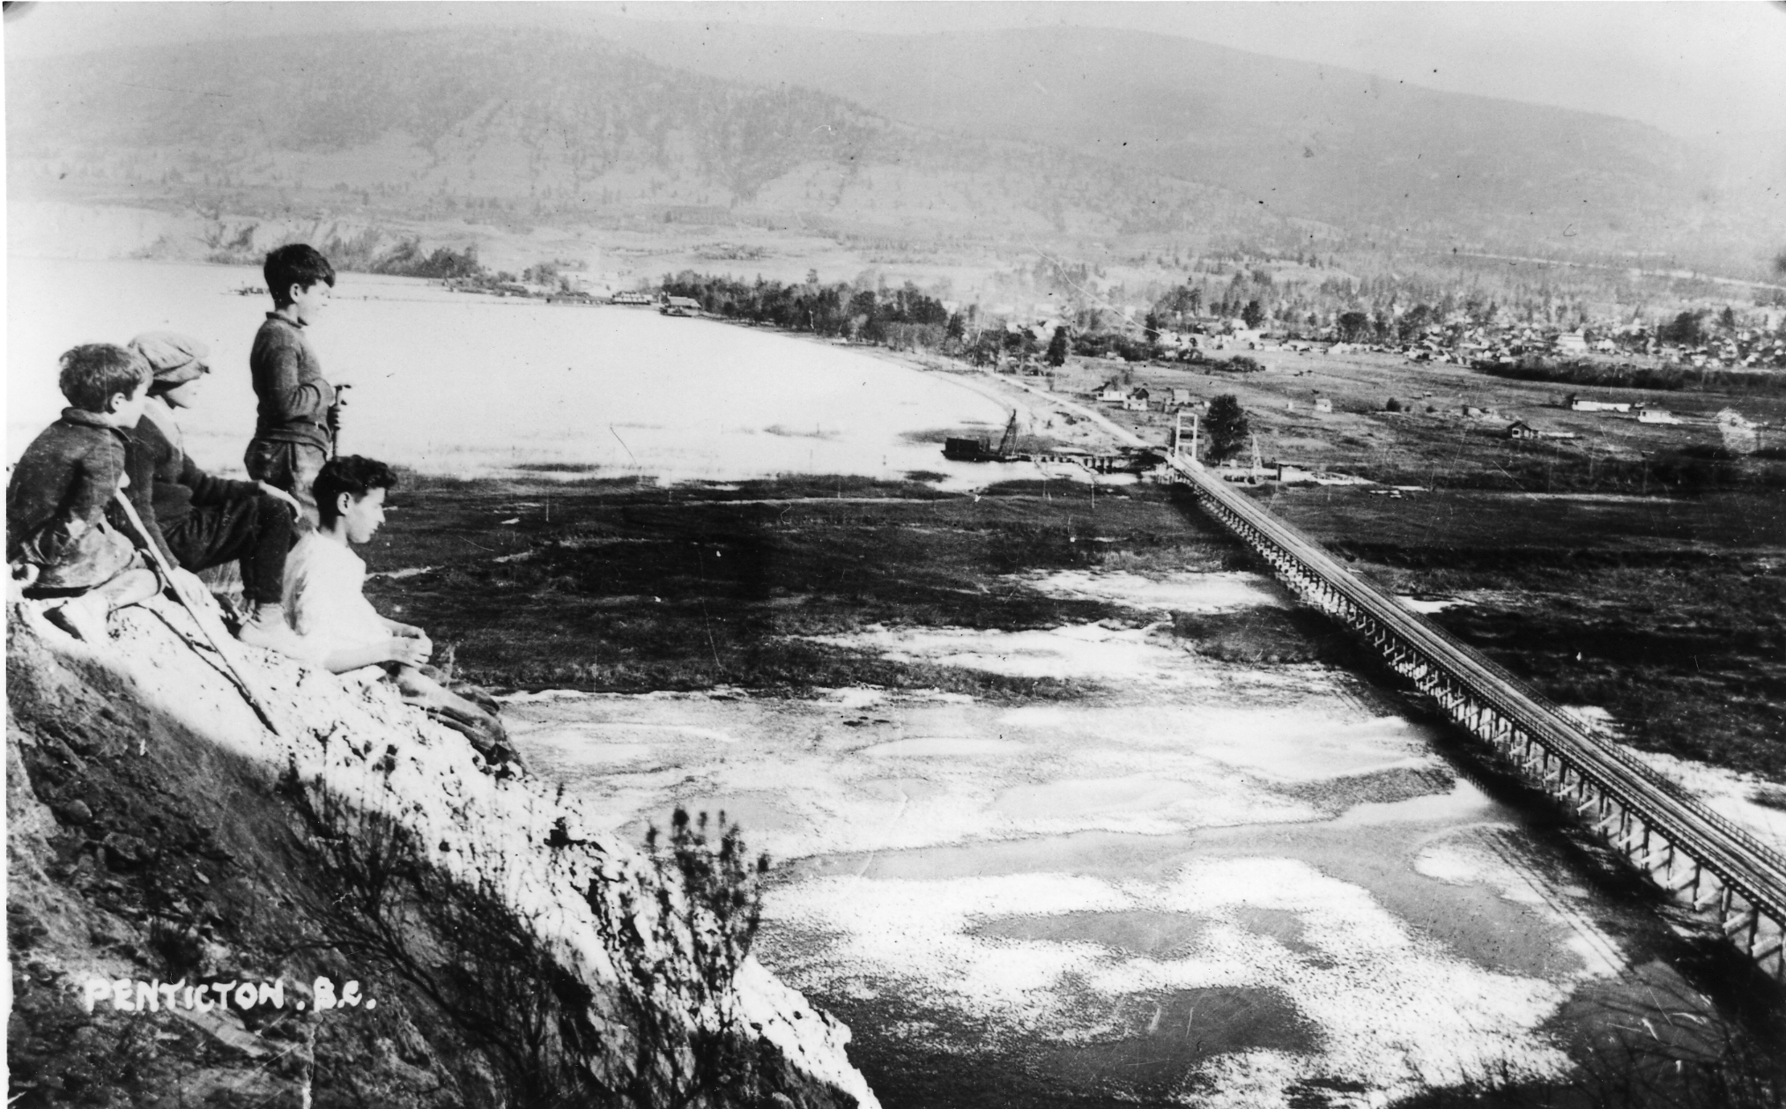
Causeway leaving Penticton onto Hwy 97 (Penticton City Archives)

Loco Landing/Riverside Marsh

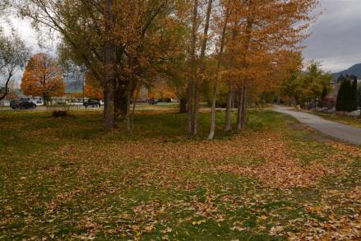
North end of remnant river channel now wet meadow, Loco Landing/Riverside Marsh

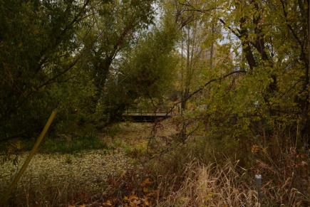
Souther part of remnant wetland near footbridge, Loco Landing/Riverside Marsh

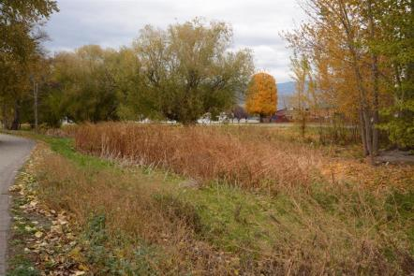
Looking north from near the footbridge, Loco Landing/Riverside Marsh

Ellis Creek Basin

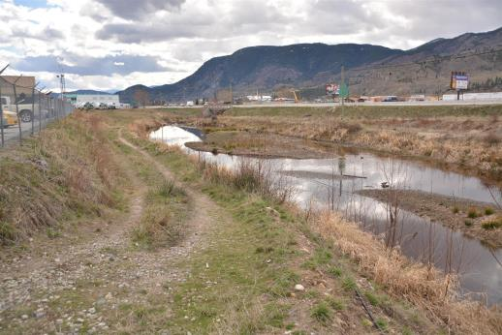
Ellis Creek basin looking south

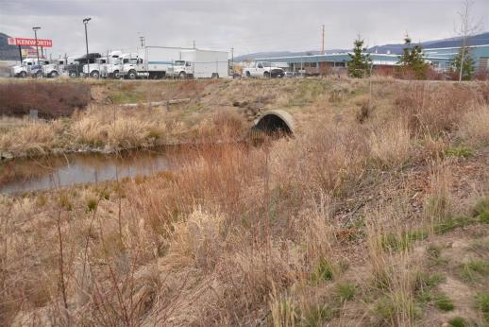
Ellis Creek culvert under old Industrial Ave road

Warren Ave

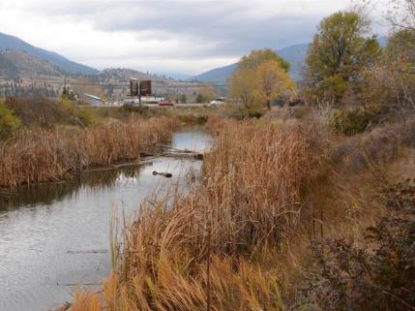
North end of Warren Ave oxbow near foot of Okanagan Ave West, looking east

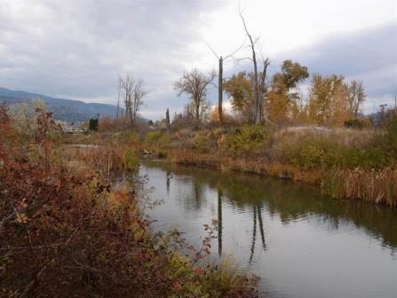
Central part of Warren Ave oxbow from Troy Ave, looking south

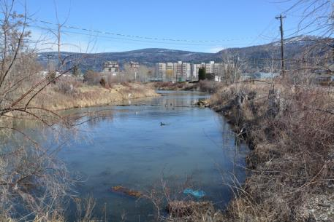
South part of Warren Ave oxbow looking east, from entrance to locatee owned land on Warren Ave

Kinney Ave

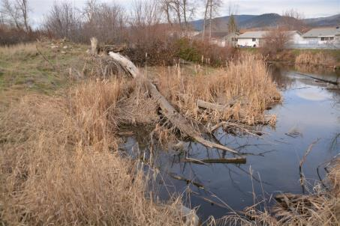
Kinney Ave oxbow from west end looking northeast

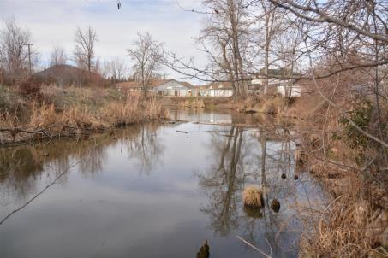
Kinney Ave oxbow from Kinney Ave looking north

Falcon Court

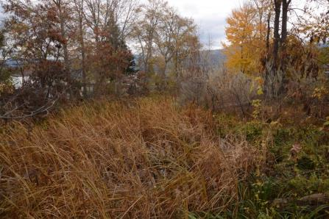
Falcon Court oxbow at north end showing heavily overgrown wetland

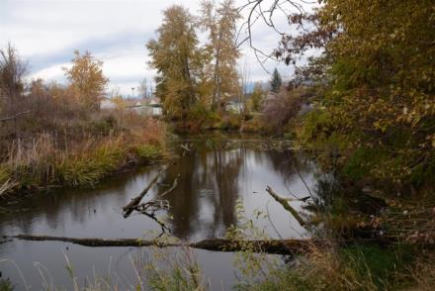
Falcon Court oxbow south end showing more open water and some riparian vegetation

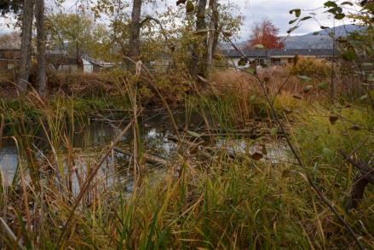
Mid-portion of Falcon Court oxbow showing good riparian and open water mix

Brandon Ave

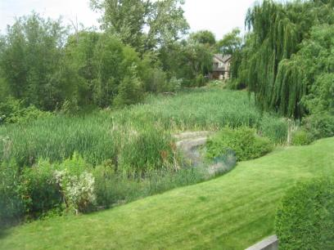
Brandon Ave oxbow near storm sewer outfall (open water)

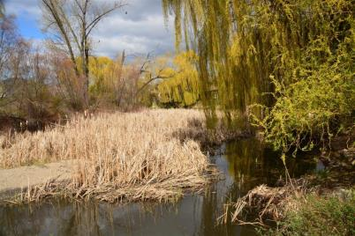
Central part of Brandon Ave oxbow looking north

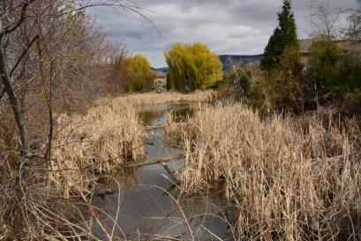
North end of Brandon Ave oxbow looking south

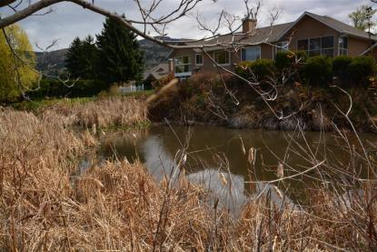
Brandon Ave oxbow west of storm sewer outfall

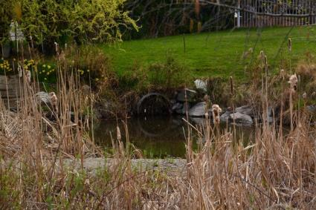
Storm sewer outfall, Brandon Ave oxbow

Campi oxbow

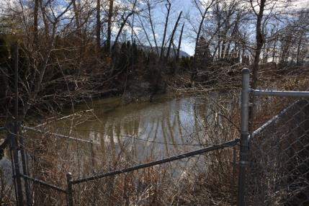
Campi oxbow looking south from new fence adjacent to Hwy 97 (Channel Parkway)

Yorkton Ave/Skaha Place

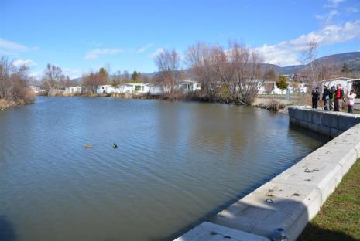
Yorkton Ave/Skaha Place oxbow from Figueiras Mobile Home Park showing extensive bank armour

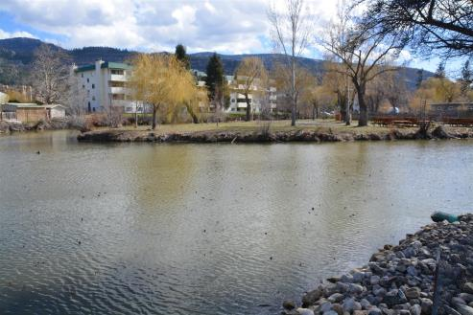
Yorkton/Skaha Place oxbow from south end of Figueiras Mobile Home Park

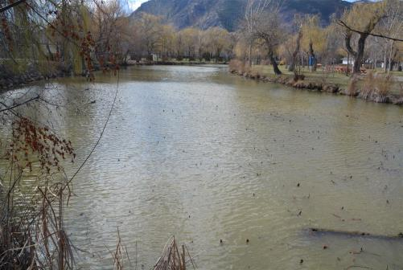
Yorkton/Skaha Place oxbow from Skaha Place looking southwest

Old River Mouth, Skaha Lake

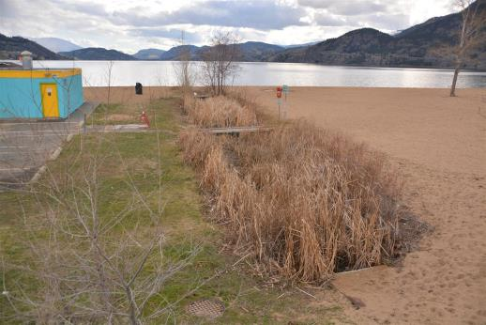
Old Okanagan River outlet into Skaha Lake looking south

ECOmmunity wetland and lowland forest area
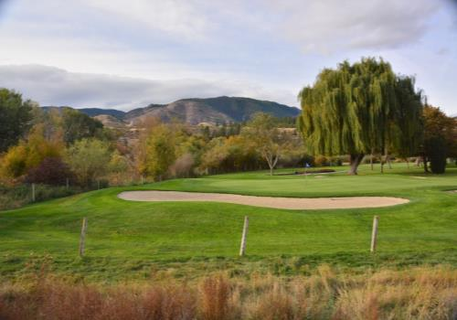
Riparian fringe beyond golf course bordering ECOmmunity wetland oxbow looking from the south
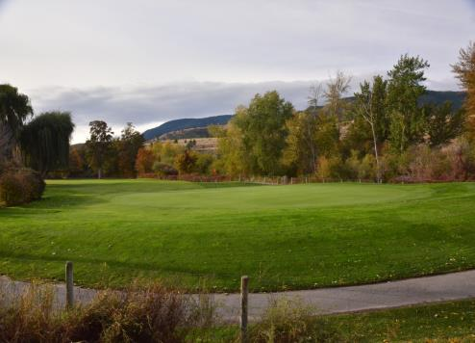
Riparian fringe beyond golf course bordering ECOmmunity wetland oxbow looking from the north

Airport Wetlands – North Pond, South Pond, and Remnant Oxbow.

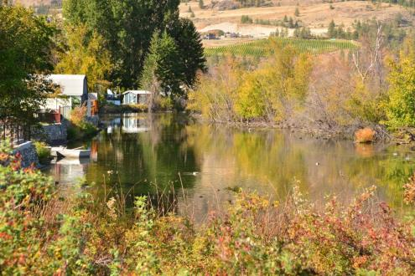
South shore of Airport Pond South showing bank encroachment on left and good riparian growth on right bank
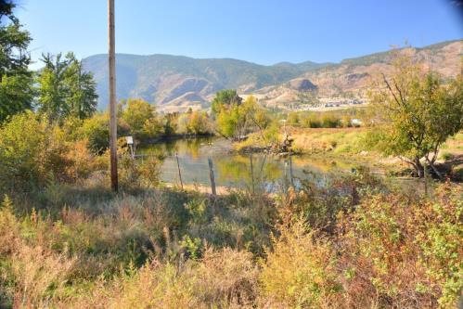
North arm of South Oxbow. Well developed riparian vegetation on left bank; degraded riparian vegetation on right bank with heavy weed infestation.

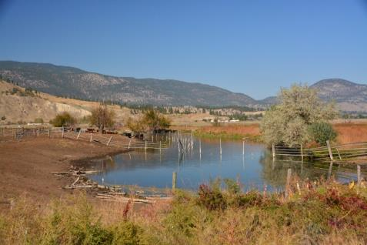
South arm of North Oxbow. Heavily degraded on both shows from grazing.

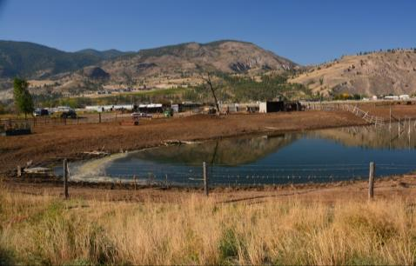
North Arm of North Oxbow. No vegetation due to excessive grazing.

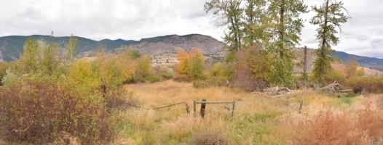
Vegetated area between north and south arms of South Oxbow.

Appendix 2. Summary of bird and turtle counts from data collected February to October 2015 by the South Okanagan Naturalists Club

 | Total Birds Seen
Date | 19-Feb | 19-Mar | 23-Apr | 21-May | 25-Jun | 23-Jul | 3-Sep | 1-Oct
Oxbow
Ellis Cr | 18 | 30 | 29 | 21 | 57 | 69 | 28 | 28
Warren Ave | 51 | 210 | 88 | 61 | 48 | 88 | 43 | 71
Kinney Ave | 2 | 7 | 2 | 14 | 0 | 0 | 3 | 6
Falcon Cr | 0 | 0 | 78 | 26 | 24 | 17 | 39 | 7
Brandon | 8 | 10 | 32 | 9 | 7 | 5 | 8 | 4
Yorkton/Skaha |  |  | 92 | 48 | 114 | 36 | 108 | 46
Total | 79 | 257 | 321 | 179 | 250 | 215 | 229 | 162

Total Species Count
Date | 19-Feb | 19-Mar | 23-Apr | 21-May | 25-Jun | 23-Jul | 3-Sep | 1-Oct
Ellis Cr | 6 | 7 | 8 | 5 | 9 | 7 | 8 | 3
Warren Ave 10 |  | 12 | 16 | 13 | 9 | 17 | 13 | 12
Kinney Ave | 2 | 3 | 1 | 4 | 0 | 0 | 2 | 2
Falcon Cr |  |  | 13 | 7 | 5 | 7 | 9 | 4
Brandon | 6 | 6 | 11 | 5 | 5 | 3 | 3 | 2
Yorkton/Skaha | 4 | 5 | 11 | 9 | 12 | 8 | 7 | 6
Total * | 14 | 18 | 28 | 21 | 22 | 22 | 28 | 18
* Total does not equal total of column as species were seen in more than one oxbow

 | Total Turtles
Date | 19-Feb | 19-Mar | 23-Apr | 21-May | 25-Jun | 23-Jul | 3-Sep | 1-Oct
Oxbow
Ellis Cr
Warren Ave |  | 4 |  | 17 | 12 | 6 | 2
Kinney Ave |  |  | 13 | 12 | 11 | 18 | 20
Falcon Cr
Brandon |  |  |  | 8 | 5
Yorkton/Skaha |  |  |  | 6 |  |  | 20
Total | 0 | 4 | 13 | 43 | 28 | 24 | 42 | 0

Bird Use days per hectare
Location | Area of water ha (est) | water bird use | other bird species use
Ellis Creek Basin | 0.2316 | 464 | 643
Warren Ave oxbow | 0.91 | 172 | 473
Kinney | 0.1765 | 57 | 113
Falcon Cr | 0.2375 | 143 | 486
Brandon Ave | 0.2 | 75 | 337.5
Yorkton/Skaha Place | 2.285 | 101 | 100

Appendix 3 Graphic summary of pH and conductivity at the Brandon Ave oxbow for the period May 2015 through September 2016, and at other sites in late 2015 to September 2016.

